Ch 12 Practice
- 2nd Aorist Stem: Match the lexical form of the verb with the 2nd Aorist form.
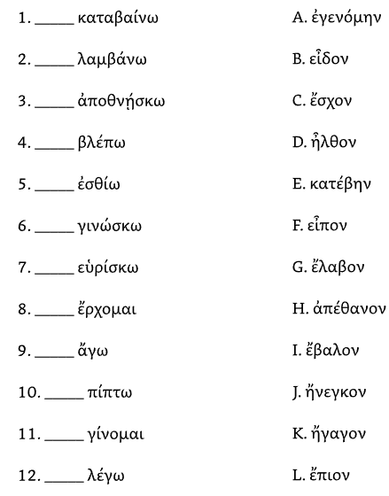
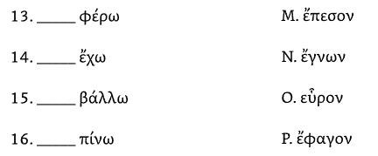

- Parse the following verbs:
1 | 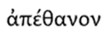
2 | 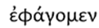
3 | 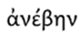
4 | 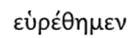
5 | 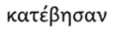
6 | 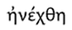
7 | 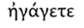
8 | 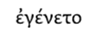
9 | 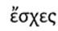
10

- Translate the following sentences:
 | Question | Notes
1
answer
2
answer
3
answer
4
answer
5
answer
6
answer
7
answer
8
answer
9 | A
answer
10
answer
11
answer
12
answer
13 | 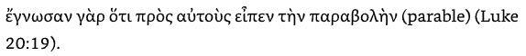
answer
14
answer
15
answer

- Translate the following into Greek:
 |  | Notes
1 | The child fell on the road.
answer
2 | You (pl) found the Lord of life.
answer
3 | He went down to the synagogue.
answer
4 | We entered into the house of God and heard the Word.
answer
5 | They spoke the promise to the crowd.
answer

